1. **INTRODUCTION:**
   1. **Overview**

* **Description of the Project**

**Project Description:**

EduConnect Learning Center, an educational institution, uses Zoho Books to manage their donations, track expenses, and handle grant finances. They can generate donor receipts, track expenses

related to educational programs, and generate financial reports. Zoho Books helps them maintain financial transparency and accountability.

* 1. **Purpose**

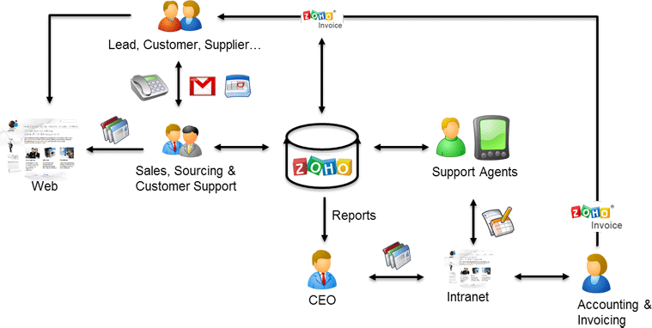

**2. Problem definition & design Thinking**

**2.1 Empathy map**

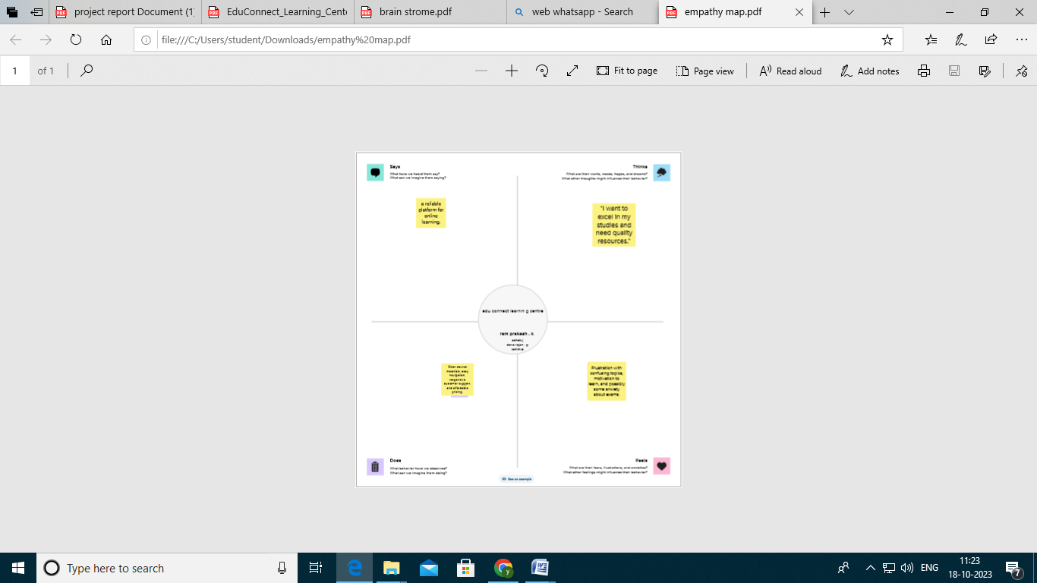

**2.2 Ideation & Brainstorming map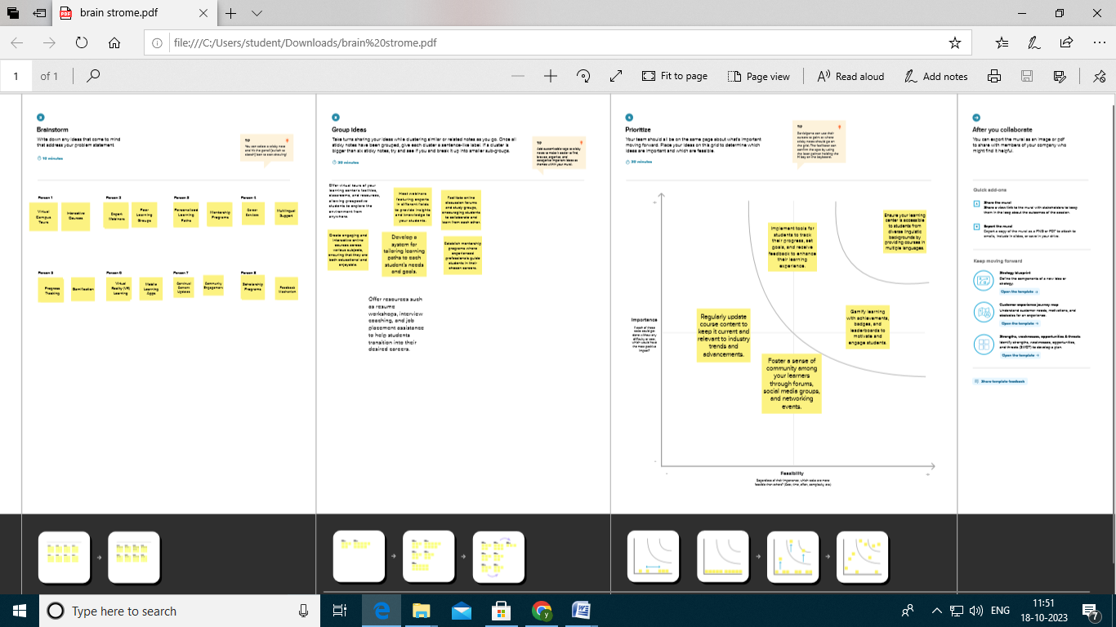:**

**3.Result:**

**Profit&loss**

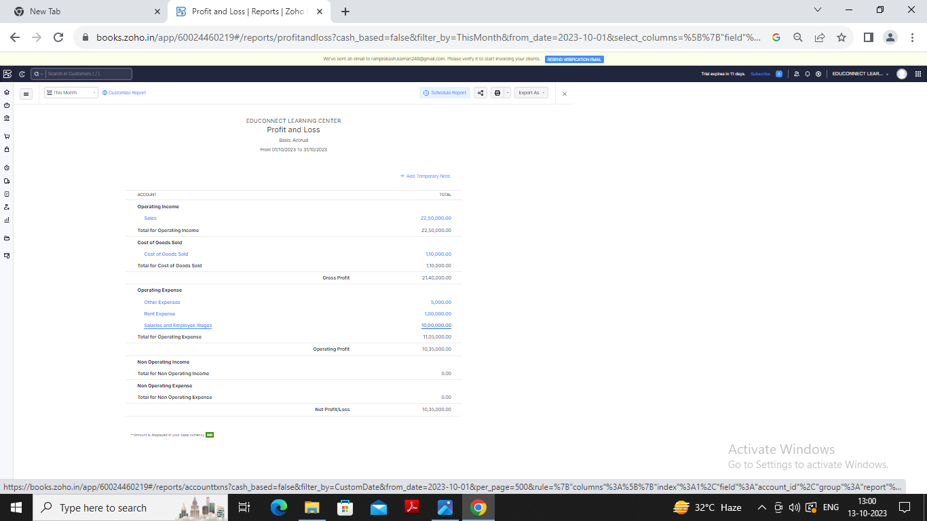

**Balance sheet:**

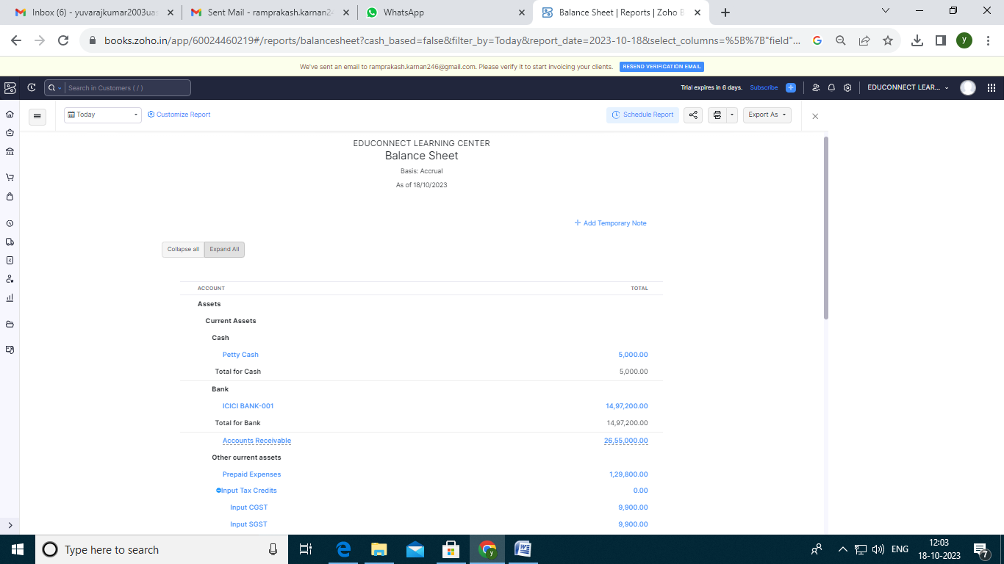

**Purchase order:**

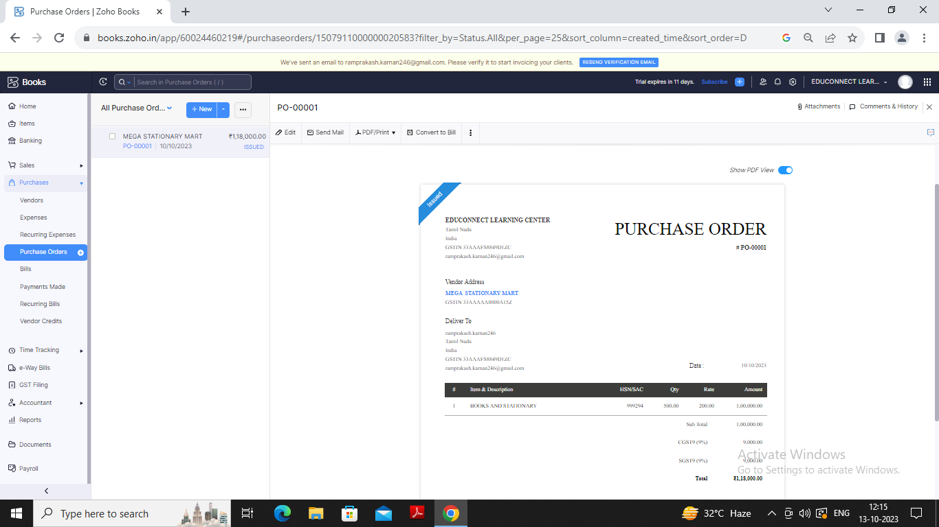

**Sales Order:**

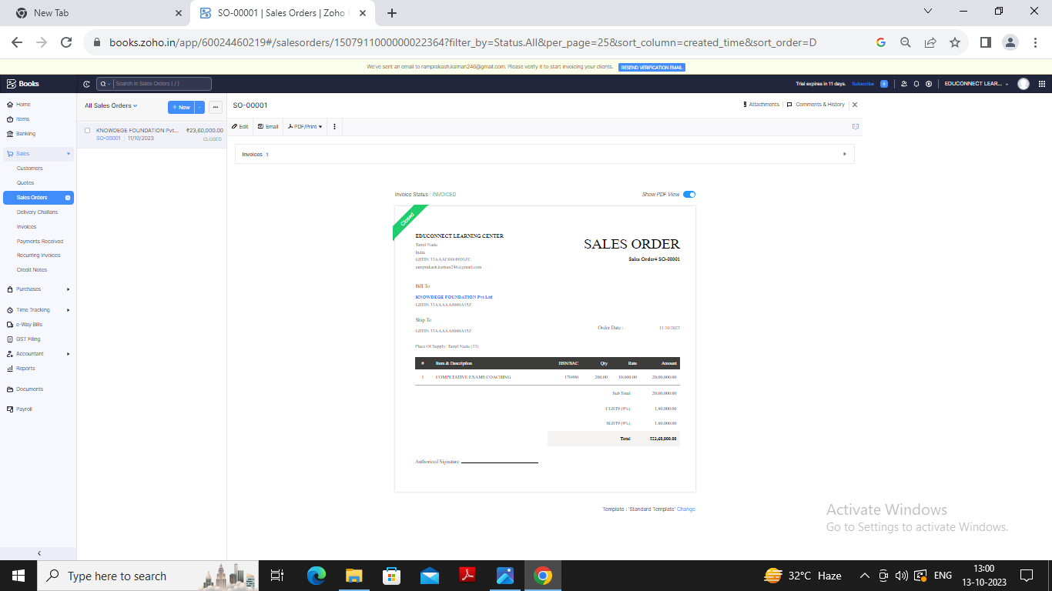

**Invoice:**

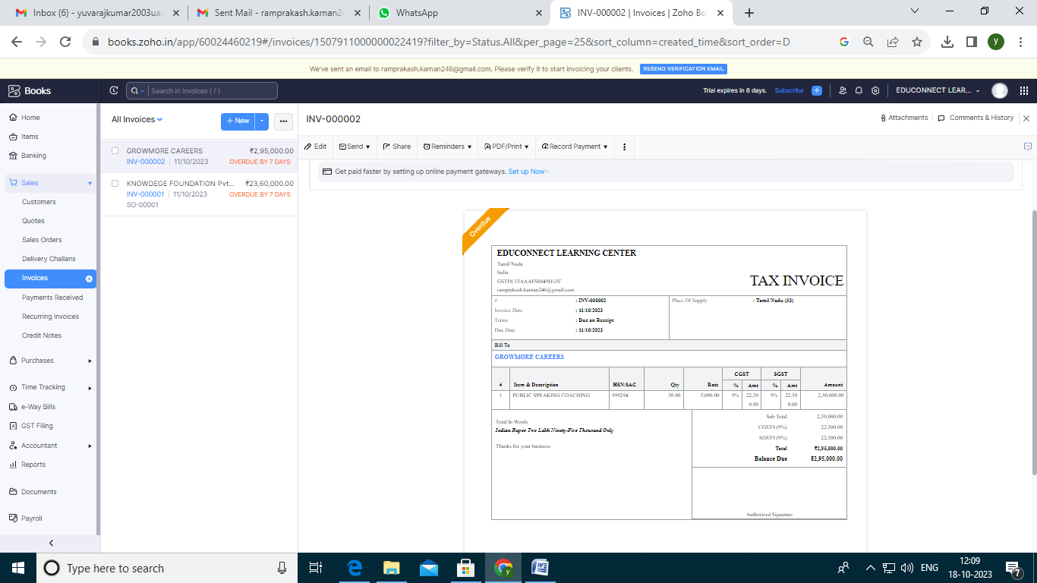

**Bill:**

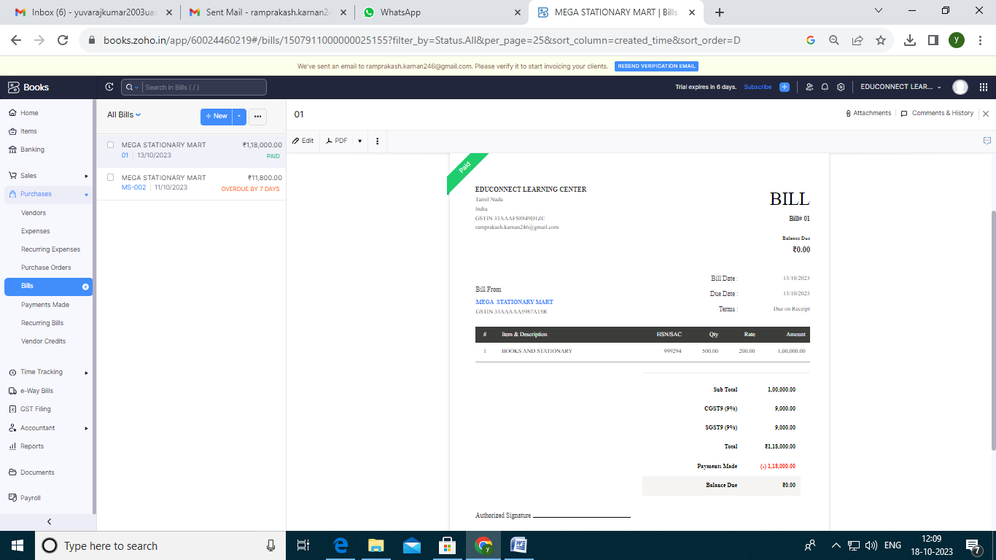

**Advantages Of Educonnect Learning Center:**

* Project EduConnect has witnessed transformative impact. Students who were once limited by their geographical location now have access to a wealth of educational resources.
* Increased attendance, improved academic performance, and a renewed enthusiasm for learning have been reported in these rural areas.
* Project EduConnect exemplifies the potential of technology to bridge educational disparities. By leveraging the power of the digital world and fostering community participation, EduConnect serves as a beacon of hope for rural students who aspire to learn and grow, regardless of the barriers that may stand in their way.

**Disadvantages Of Educonnect Learning Center:**

* Their resistance to change doesn’t allow them to adapt to the online learning environment, whereas it takes time for them to get accustomed to Course Management Systems (CMS) and the methods of computer-based education.
* Many students are not provided with the high bandwidth or the strong internet connection that online courses require, and thus fail to catch up with their virtual classmates: Their weak monitors make it hard to follow the Course Management System and their learning experience becomes problematic.
* Time management is a difficult task for eLearners, as online courses require a lot of time and intensive work. Furthermore, whereas it is mostly adults who prefer web-based learning programs for their place and time flexibility, they rarely have the time to take the courses due to their various everyday commitments.

**APPENDIX:**

[**https://github.com/ramprakashrohith/edu-connect-learning-center_NM2023TMID22805**](https://github.com/ramprakashrohith/edu-connect-learning-center_NM2023TMID22805)

|  |
| --- |
|  |
| <!DOCTYPE html> |
|  | <html lang="en" data-color-mode="auto" data-light-theme="light" data-dark-theme="dark" data-a11y-animated-images="system" data-a11y-link-underlines="false"> |
|  |  |
|  | <style> |
|  | /* for each iteration, uncomment the CSS variable */ |
|  |  |
|  | /* light themes */ |
|  | [data-color-mode="light"][data-light-theme*="light"], |
|  | [data-color-mode="auto"][data-light-theme*="light"] { |
|  | /* iteration 1 */ |
|  | --border-color-iteration-1: #C8CCD0; |
|  | /* iteration 2 */ |
|  | --border-color-iteration-2: #BABFC5; |
|  | /* iteration 3 */ |
|  | --border-color-iteration-3: #A6ADB4; |
|  | /* iteration final */ |
|  | --border-color-iteration-4: #868F99; |
|  |  |
|  | /* the first value is the final step, which falls back to previous iterations */ |
|  | --control-borderColor-rest: var(--border-color-iteration-4, var(--border-color-iteration-3, var(--border-color-iteration-2, var(--border-color-iteration-1)))) !important; |
|  | } |
|  |  |
|  | /* dark themes */ |
|  | [data-color-mode="dark"][data-dark-theme*="dark"], |
|  | [data-color-mode="auto"][data-light-theme*="dark"] { |
|  | /* iteration 1 */ |
|  | --border-color-iteration-1: #363940; |
|  | /* iteration 2 */ |
|  | --border-color-iteration-2: #3F434B; |
|  | /* iteration 3 */ |
|  | --border-color-iteration-3: #4B5159; |
|  | /* iteration final */ |
|  | --border-color-iteration-4: #666E79; |
|  |  |
|  | /* the first value is the final step, which falls back to previous iterations */ |
|  | --control-borderColor-rest: var(--border-color-iteration-4, var(--border-color-iteration-3, var(--border-color-iteration-2, var(--border-color-iteration-1)))) !important; |
|  | } |
|  |  |
|  | [data-color-mode="dark"][data-dark-theme="dark_dimmed"], |
|  | [data-color-mode="dark"][data-dark-theme="light_high_contrast"], |
|  | [data-color-mode="dark"][data-dark-theme="dark_high_contrast"], |
|  | [data-color-mode="light"][data-light-theme="dark_dimmed"], |
|  | [data-color-mode="light"][data-light-theme="light_high_contrast"], |
|  | [data-color-mode="light"][data-light-theme="dark_high_contrast"] { |
|  | /* skip these themes, use the fallback */ |
|  | --control-borderColor-rest: initial !important; |
|  | } |
|  |  |
|  | @media (prefers-color-scheme: dark) { |
|  | /* dark colors in dark mode */ |
|  | [data-color-mode="auto"][data-dark-theme*="dark"] { |
|  | /* iteration 1 */ |
|  | --border-color-iteration-1: #363940; |
|  | /* iteration 2 */ |
|  | --border-color-iteration-2: #3F434B; |
|  | /* iteration 3 */ |
|  | --border-color-iteration-3: #4B5159; |
|  | /* iteration final */ |
|  | --border-color-iteration-4: #666E79; |
|  |  |
|  | /* the first value is the final step, which falls back to previous iterations */ |
|  | --control-borderColor-rest: var(--border-color-iteration-4, var(--border-color-iteration-3, var(--border-color-iteration-2, var(--border-color-iteration-1)))) !important; |
|  | } |
|  |  |
|  | /* light colors in dark mode */ |
|  | [data-color-mode="auto"][data-dark-theme*="light"] { |
|  | /* iteration 1 */ |
|  | --border-color-iteration-1: #C8CCD0; |
|  | /* iteration 2 */ |
|  | --border-color-iteration-2: #BABFC5; |
|  | /* iteration 3 */ |
|  | --border-color-iteration-3: #A6ADB4; |
|  | /* iteration final */ |
|  | --border-color-iteration-4: #868F99; |
|  |  |
|  | /* the first value is the final step, which falls back to previous iterations */ |
|  | --control-borderColor-rest: var(--border-color-iteration-4, var(--border-color-iteration-3, var(--border-color-iteration-2, var(--border-color-iteration-1)))) !important; |
|  | } |
|  |  |
|  | [data-color-mode="auto"][data-dark-theme="dark_dimmed"], |
|  | [data-color-mode="auto"][data-dark-theme="light_high_contrast"], |
|  | [data-color-mode="auto"][data-dark-theme="dark_high_contrast"] { |
|  | /* skip these themes, use the fallback */ |
|  | --control-borderColor-rest: initial !important; |
|  | } |
|  | } |
|  |  |
|  | @media (prefers-color-scheme: light) { |
|  | /* dark colors in light mode */ |
|  | [data-color-mode="auto"][data-light-theme*="dark"] { |
|  | /* iteration 1 */ |
|  | --border-color-iteration-1: #363940; |
|  | /* iteration 2 */ |
|  | --border-color-iteration-2: #3F434B; |
|  | /* iteration 3 */ |
|  | --border-color-iteration-3: #4B5159; |
|  | /* iteration final */ |
|  | --border-color-iteration-4: #666E79; |
|  |  |
|  | /* the first value is the final step, which falls back to previous iterations */ |
|  | --control-borderColor-rest: var(--border-color-iteration-4, var(--border-color-iteration-3, var(--border-color-iteration-2, var(--border-color-iteration-1)))) !important; |
|  | } |
|  |  |
|  | /* light colors in light mode */ |
|  | [data-color-mode="auto"][data-light-theme*="light"] { |
|  | /* iteration 1 */ |
|  | --border-color-iteration-1: #C8CCD0; |
|  | /* iteration 2 */ |
|  | --border-color-iteration-2: #BABFC5; |
|  | /* iteration 3 */ |
|  | --border-color-iteration-3: #A6ADB4; |
|  | /* iteration final */ |
|  | --border-color-iteration-4: #868F99; |
|  |  |
|  | /* the first value is the final step, which falls back to previous iterations */ |
|  | --control-borderColor-rest: var(--border-color-iteration-4, var(--border-color-iteration-3, var(--border-color-iteration-2, var(--border-color-iteration-1)))) !important; |
|  | } |
|  |  |
|  | [data-color-mode="auto"][data-light-theme="dark_dimmed"], |
|  | [data-color-mode="auto"][data-light-theme="light_high_contrast"], |
|  | [data-color-mode="auto"][data-light-theme="dark_high_contrast"] { |
|  | /* skip these themes, use the fallback */ |
|  | --control-borderColor-rest: initial !important; |
|  | } |
|  | } |
|  | </style> |
|  |  |